Joint Crediting Mechanism Guidelines for Developing Proposed Methodology for Reducing Emissions from Deforestation and Forest Degradation, and the Role of Conservation, Sustainable Management of Forests and Enhancement of Forest Carbon Stocks in Developing Countries (REDD-plus) and Afforestation/Reforestation (Draft)

CONTENTS

1. Scope and applicability 2
2. Terms and definitions 2
3. Key concepts 3
3.1. Project emission reductions or removals to be credited in a JCM project for REDD-plus and afforestation/reforestation 3
3.2. Scope and criteria for afforestation/reforestation under the JCM 4
3.3. Eligibility criteria 5
4. Requirements for REDD-plus and afforestation/reforestation under the JCM 5
4.1. Period of time 5
4.2. Forest Definition 6
4.3. Geographical Boundaries 6
4.4. Carbon pools and GHG sources 7
4.5. Estimation and accounting of net emission/removals 7
4.6. Project reference level 8
4.7. Project net emissions or removals 9
4.8. Project emission reductions or removals to be credited 10
5. General Guidelines 10
6. Instructions for completing the Proposed Methodology Form 12
7. Instructions for completing the Proposed Methodology Spreadsheet 20
Annex I. Guidance on the long-term average GHG benefit for A/R project 27
Annex II. National definition of forest under the JCM of the PARTNER COUNTRY 29
Annex III. Guidance on buffer approach to address reversals 30

- Scope and applicability
- Joint Crediting Mechanism Guidelines for Developing Proposed Methodology for Reducing Emission from Deforestation and Forest Degradation, and the Role of Conservation, Sustainable Management of Forests and Enhancement of Forest Carbon Stocks in Developing Countries (REDD-plus) and afforestation/reforestation (hereinafter referred to as “these Guidelines”) are intended to assist methodology proponents in preparing proposed methodologies for REDD-plus and afforestation/reforestation under the Joint Crediting Mechanism (JCM).
- These Guidelines are to be referred to by the Joint Committee in developing and assessing proposed methodologies. These Guidelines are also to be referred to throughout the entire project cycle of a JCM project for REDD-plus (hereinafter referred to as "a REDD-plus project”) and for afforestation/reforestation (hereinafter referred to as "an A/R project”).
- These Guidelines describe standards which are requirements to be met, except guidance indicated with terms “should” and “may” as defined in paragraph 7 below.
- Submission and subsequent assessment of a proposed methodology are conducted in line with the procedure delineated in Joint Crediting Mechanism Project Cycle Procedure for REDD-plus and afforestation/reforestation.
- These Guidelines aim to assist the development of methodologies to quantify emissions reductions or removals from the five REDD-plus activities listed in the Cancun Agreements (UNFCCC, Decision 1/CP.16 paragraph 70), i.e. (a) reducing emissions from deforestation; (b) reducing emissions from forest degradation; (c) conservation of forest carbon stocks; (d) sustainable management of forests; and (e) enhancement of forest carbon stocks, and from afforestation/reforestation. Detailed scope of afforestation/reforestation under the JCM is described in the section 3.2 of these guidelines.
- For REDD-plus, these guidelines are applied to in developing proposed methodology for projects which are to be implemented under the national REDD-plus strategy and with respect to the national or any relevant sub-national reference level and forest monitoring system established by the PARTNER COUNTRY.

- Terms and definitions
- The following terms apply in this Guidelines:
(a) “Should” is used to indicate that among several possibilities, one course of action is recommended as particularly suitable;
(b) “May” is used to indicate what is permitted.
- Terms in these guidelines are defined in JCM Glossary of Terms available on the JCM website.

- Key concepts
  - Project emission reductions or removals to be credited in a JCM project for REDD-plus and afforestation/reforestation
- In a JCM project for REDD-plus or afforestation/reforestation, the project emission reductions or removals to be credited are defined as the sum of the annual emission reductions or removals resulting from project activities during a crediting period. A certain portion of the JCM credits issued from the REDD-plus project and the A/R project is deposited as buffer credits in the buffer account in order to ensure the permanence of the JCM credit issued from the project.
- The annual emission reductions or removals are a conservative estimate of the difference between the project reference level and project net emissions or removals in each year.
- The project reference level is an estimate of the anticipated annual net emissions/removals in the project area during the crediting period without the project being implemented. Guidelines for methodologies on setting out the procedures for establishing project reference levels are provided in paragraphs 44 to 48 in these Guidelines.
- The project net emissions or removals is the sum of actual emissions and removals in the project area, emissions and removals from the project activities and emissions displaced to outside of the project area by the project activities during the crediting period. Guidelines for methodologies on setting out the procedures to estimate the project net emissions or removals are provided in paragraphs 49 to 53 in these Guidelines.

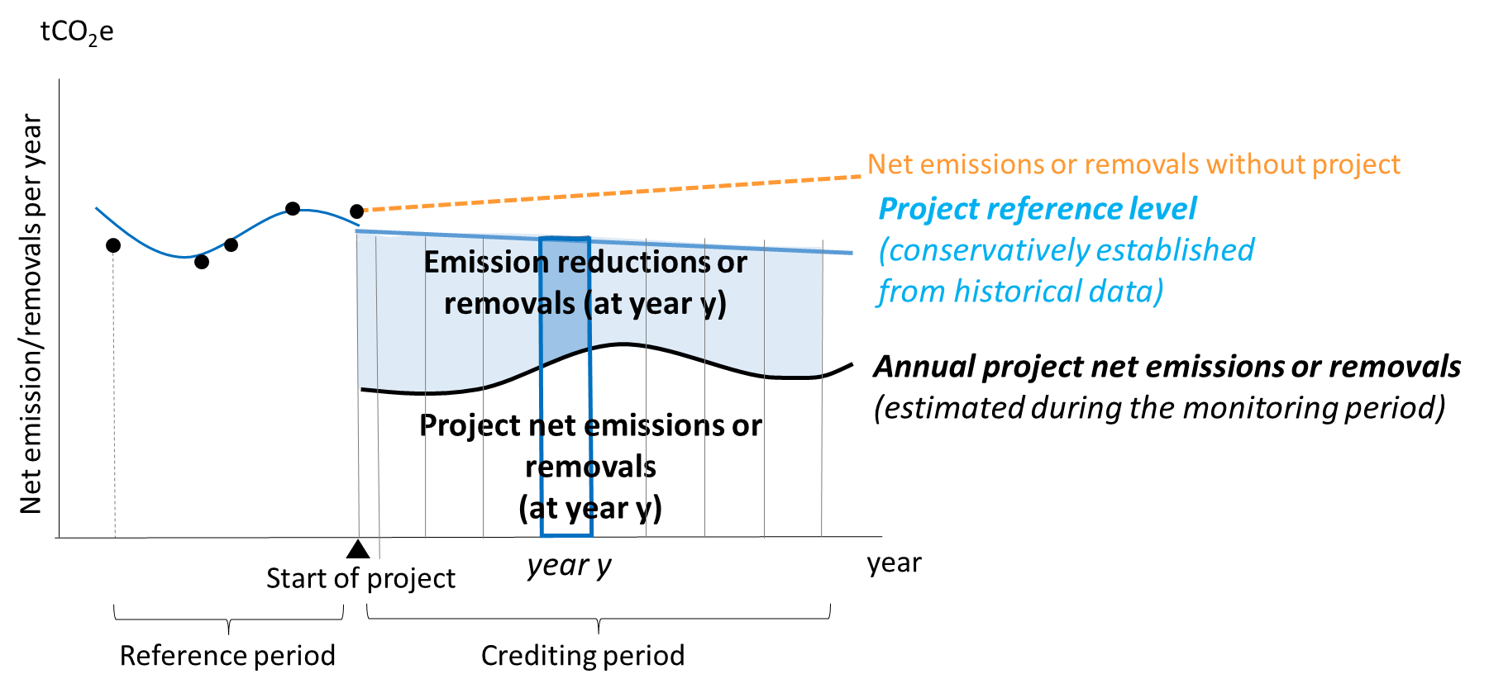
Figure 1: Relationship between the project reference level, annual project net emissions or removals, annual emission reductions or removals for REDD-plus project

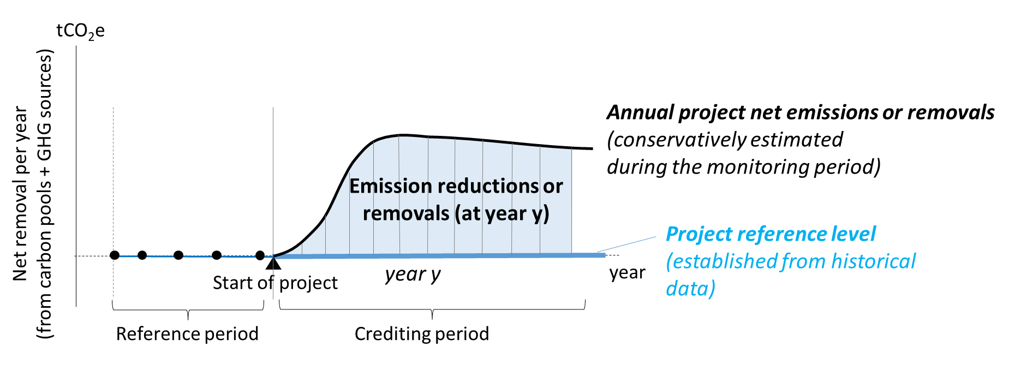
Figure 2: Relationship between the project reference level, annual project net emissions or removals, annual emission reductions or removals for A/R project

  - Scope and criteria for afforestation/reforestation under the JCM
- Eligible afforestation/reforestation activities under the JCM are those that convert from non-forest, including those in denuded forest and previously forested areas to forest through the planting, sowing and human-assisted natural regeneration of woody vegetation.
- Regarding implementation of an A/R project, project participants should ensure by providing no-objection letter from PARTNER COUNTRY’s government:
- that activity is to convert land use or land cover from non-forest to forest
- that afforestation/reforestation will be implemented for the project.
- Project participants demonstrate that the project area has not been cleared of native ecosystems within the 10 year period before the project start date. In the case when the project area has been cleared during the last 10 years prior to the project start date, the eligibility of the A/R project is determined by the Joint Committee. Project participants provide evidence that such land clearance has not taken place with an intention to implement project activities.
- Eligible A/R project is to increase carbon stock and/or reduce emissions in the project area by the project activities during the crediting period and to ensure the permanence of the JCM credit issued from the project. The definition of the types of period including crediting period, observation period and project period is provided in the section 4.1 of these guidelines and in the JCM Glossary of Terms.
- Project participants maintain forest in the project area after the crediting period. Project participants observe the status of forest to the JCM secretariat during the observation period.
- Eligible A/R project is to implement the project activities referred to in paragraph 13 above, and to aim for mitigation of climate change as one of the main objectives. Where the A/R project is not economically feasible only by issuance of the JCM credits, such in case investment barriers prevent the implementation of the project, project participants may implement commercial activities (such as timber production) in the project area. In this case, project participants demonstrate economical additionality that commercial activities other than credit issuance implemented during the crediting period is not to be implemented without the project.
- Planting activity and tree species are in line with requirements in PARTNER COUNTRY’s national biodiversity strategy, the Nationally Determined Contributions and published document provided by national or regional government including national/regional strategy and/or plan. In case there is no source of information described above, project participants confirm no objection of planting activity and tree species through consultation with government of the PARTNER COUNTRY.
- For an A/R project with harvesting, the total amount of JCM credits issued does not exceed the cumulative net emission reductions or removals during the entire crediting period. To ensure that, upper limit of the amount of credit issuance is applied based on future harvesting plans. One of approaches to set the upper limit is the long-term average GHG benefit. Details of the approach applying the long-term average GHG benefit are provided in Annex I of these guidelines. Project participants may set their own upper limit of the amount of credit issuance, which is more conservative than the long-term average GHG benefit. In this case, the method to set the conservative upper limit is described in the proposed methodology. In case that the total amount of JCM credits issued is above the cumulative net emission reductions or removals in the project area, it is regarded as a reversal, and project participants compensate the difference between total amount of JCM credits issued and the cumulative net emission reductions or removals by cancellation of their buffer credits.

  - Eligibility criteria
- Eligibility criteria in proposed methodologies contain the following:
- Requirements for the project in order to be registered as a JCM project.
- Requirements for the project to be able to apply the approved methodology.

- Requirements for REDD-plus and afforestation/reforestation under the JCM
  - Period of time
- Project period consists of the total crediting period and the observation period.
- Crediting period is the period in which verified emission reductions or removals attributable to a JCM project can result in the issuance of JCM credits from that JCM project. The crediting period for REDD-plus and A/R is a renewable period of a maximum of fifteen (15) years which may be renewed twice at the maximum. Where possible, the total crediting period for REDD-plus and afforestation/reforestation including renewal of the period should be more than 20 years.
- Observation period is the period in which project participants observe whether verified emission reductions or removals are ensured and whether loss events happen, as one of means to ensure the permanence of issued JCM credits. The observation period begins at the end of the crediting period.
- Project participants apply the project period in the way that observation period is at least 10 years, or that project period is at least 30 years, whichever the project period is longer.
- During the observation period, project participants implement “observation activities”, described in para 27. In case a loss event occurs, project participants report the event and risk of non-permanence. Buffer credits are cancelled to compensate the loss in line with relevant procedures to be determined by Japanese government or the Joint Committee.
- Observation activities is implemented to observe the status of the project area during the observation period by using satellite images, remote sensing and/or others specified in a proposed methodology.

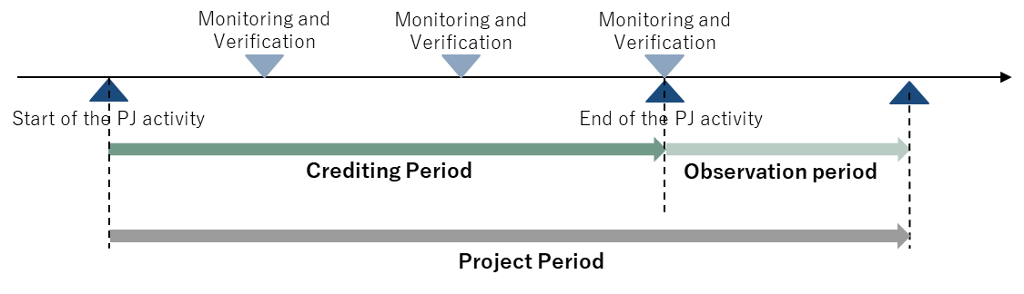
Figure 3: Period of time

  - Forest Definition
- The definition of forest used for REDD-plus and afforestation/reforestation methodologies should follow the national definition of forest designated by the PARTNER COUNTRY, as specified in Annex II of these Guidelines. If there is a difference between the national definition of forest and the definition used in a proposed methodology, the reason for selecting the forest definition is explained.
- Non-forest is the land which does not meet the definition of forest.

  - Geographical Boundaries
- For REDD-plus project, the project area and the reference area for the project are identified. Also, a displacement belt and/or activity area are also identified, when necessary. The project area and the activity area are delineated taking into account forest management units and other administrative boundaries as well as local land management customs.
- For A/R project, the project area for the project is identified. Also, a reference area, displacement belt and/or activity area are also identified, when necessary. The project area and the activity area are delineated taking into account forest management units and other administrative boundaries as well as local land management customs.
- The project area is the area targeted for reducing emissions and/or enhancing removals.
- The reference area is the area used to establish the project reference level. The reference area is similar to the project area with respect to landscape configuration and ecological condition, and socio-economic and cultural conditions.
- The displacement belt is the area outside the project area where emissions displaced through activity shifting by implementation of the project will be monitored. Guidelines for accounting for displaced emissions are provided in paragraph 50 below.
- The activity area is the area where project activities are implemented to reduce emissions and/or increase removals in the project area and to reduce the risk of the displacement of emissions to other areas.
- At the time of validation, at least 80 percent of the project area is under the control of the project, and acquisition of the rights of use of the project area to the extent necessary for the project is demonstrated by the project participants with documentary evidence. By the time of the first verification event, the entire project area is under the control of the project, and acquisition of the entire rights of use of the project area to the extent necessary for the project is demonstrated as such by the project participants with documentary evidence.

  - Carbon pools and GHG sources
- The carbon stocks to be considered includes each of the following five carbon pools: above ground biomass, below-ground biomass, dead wood, litter and soil organic carbon.
- GHG sources to be considered are sources such as biomass burning, enteric fermentations of livestock, rice cultivation, and nitrogen fertilization for CH₄ and N₂O and fuel consumed by project activities for CO₂.

  - Estimation and accounting of net emission/removals
- The approach and procedures used for the national or any relevant sub-national reference level or forest monitoring system developed by the PARTNER COUNTRY are respected when developing the project reference level and estimating net emissions or removals of the project. The guidelines in paragraphs 41 to 42 are followed when alternative or additional approaches and procedures are used. The methodology proponents communicate with the government of Japan and the government of the PARTNER COUNTRY (hereinafter referred to as “both governments”) for REDD-plus and afforestation/reforestation under the JCM to explain the proposed approach and procedures to develop the project reference level and estimate project net emissions or removals, consider any comments and other feedback they receive, and keep records of the communications.
- When estimating net emissions or removals, the most recent IPCC guidelines, such as 2006 IPCC Guidelines for National GHG Inventories, 2019 Refinement to the 2006 IPCC Guidelines for National Greenhouse Gas Inventories or the IPCC 2003 Good Practice Guidance for Land Use, Land-Use Change and Forestry, are principally used.
- The monitoring of net emissions or removals from the carbon pools in a crediting period should be conducted using a combination of remote sensing and ground-based survey. The best available technology, including novel satellite observation technologies, may be employed to build effective monitoring systems for net emissions or removals.
- Remote sensing: Forest/non-forest, land cover types and forest type should be classified through remote sensing analysis using satellite imageries whose spatial resolution is 30 meters or higher. For the classification of land cover and forest types, classification to reflect the amount of carbon stock per hectare is encouraged and the classification should reflect each country’s forest designations. The accuracy of imagery analyses of forest/non-forest classification for each forest type is 80 percent or higher.
- Ground-based survey: Emission factors, or carbon stocks per hectare, of each carbon pool in each class, should be obtained through on-the-ground measurements. If ground measurements are not used, a reasonable explanation is provided, and the IPCC's Emission Factor Database (EFDB), national forest inventories or other internationally recognized data may be used as alternative data sources for the emission factors, with an explanation of the rational for and validity of the data provided.
- To establish the project reference level, carbon pools and GHG sources can be excluded if their exclusion leads to conservative estimates of emission reductions or removals.
- To estimate project net emissions or removals, net emissions or removals from all carbon pools and GHG sources should be estimated. However, if the net emission or removals from any carbon pool or any single GHG source due to project activities is estimated to amount to less than five percent of the cumulative net emissions or removals according to measured values or data from the IPCC’s guidelines, Emission Factor Database (EFDB), national forest inventories or other internationally recognized sources, a simple but conservative procedure may be used to estimate the amount, and ex post monitoring is not necessary.

  - Project reference level
- The project reference level is a projection of the sum of the annual net emissions or removals in the project area in the absence of the project. Project reference levels should be established based on the net emissions or removals from the project area or the reference area during the reference period unless otherwise specified in the proposed methodologies to be conservative.
- For REDD-plus project, the project reference level applies the approach and procedures used for the national or any relevant sub-national reference level established by the PARTNER COUNTRY. The guidelines in paragraphs 46 to 47 are followed when alternative or additional approaches and procedures are used.
- The start of the reference period dates back at least 10 years from the start of the project. The methodology proponents may designate a maximum date back period of the historical data to be used for developing the reference levels that is appropriate for the methodology. For REDD-plus project, the data of net emissions or removals to establish the project reference level should be obtained for at least four point of times. This means that carbon stock data from at least five points in time are required when using the stock-change method to estimate net emissions or removals.
- Three approaches for establishing the project reference level are recognized:
- Average of annual net emissions or removals during the reference period;
- Single regression models of the historical trends of annual net emissions or removals;
- Other sophisticated models, including multiple regression analysis of annual net emissions or removals, taking into account possible changes in drivers of deforestation and/or forest degradation, such as changes in demography, agricultural, forestry and other land use activities, and national and/or sub-national circumstances such as land development policies and programs.
- For REDD-plus project, if a national or relevant sub-national reference level is established or changed after the project start date, the project reference level is reestablished in a consistent manner with the national or relevant sub-national reference level. However, the newly established project reference level cannot be applied retroactively to evaluate net emission reductions or removals. If there is no national or relevant sub-national reference level, the project reference level is reassessed by project participants within five years to ensure that it adequately reflects the actual circumstances of the project area, such as drivers of deforestation and/or forest degradation, activities that lead to land-use changes, and changes of forest management methods. If the result of reassessment shows that the project reference level no longer adequately reflects actual circumstances, the project reference level is reestablished.

  - Project net emissions or removals
- Project net emissions or removals include (a) the net emissions or removals in the project area, (b) emissions due to the project activities inside and outside the project area including safeguards activities, and (c) displaced emissions in each year during the crediting period.
- Displaced emissions are emissions displaced from inside to outside the project area as a result of the project activities. The two types of displaced emissions are:
- Displaced emissions through activity shifting occurs when the activities with GHG emissions which had been implemented in the project area before the project start date move to an area outside of the project area and continue its emissions elsewhere.
- Displaced emissions through change in market occurs when projects reduce the production of a commodity causing a change in the supply and market demand equilibrium that results in a shift of production elsewhere to make up for the lost supply.
- Displaced emissions through activity shifting is monitored in displacement belt and accounted. Displaced emissions through change in market is encouraged to be accounted. Any decrease in carbon stocks and increase of emissions outside the project area that are reasonably attributable to the project activities are quantified and accounted as displaced emissions. Any increase in carbon stocks and decrease of emissions compared to the situation without the project outside the project area due to the project activities are excluded from the accounting. The ways and means to identify and quantify displaced emissions are explained in the proposed methodologies.
- For REDD-plus, the approach and procedures used in any national or sub-national forest monitoring system relevant to the project area established by the PARTNER COUNTRY are considered when establishing the monitoring system for project net emissions or removals.
- Monitoring is implemented at least just prior to verifications.

  - Project emission reductions or removals to be credited
- The methodology proponents demonstrate that the method to estimate annual emission reductions or removals is conservative.
- As provided in the figure 1 in the section 3, annual project emission reductions or removals to be credited are calculated for each year from the project reference level and the project net emissions or removals. Their sum is the project emission reductions or removals to be credited during a monitoring period.
- In order to ensure that reversals are addressed in full when reversals of emission reductions or removals occur, a portion of issued JCM credits is deposited as buffer credits in the buffer account of the JCM registry. Details of this buffer approach are provided in Annex III of these guidelines.
- The project participants reduce, as far as is practical, uncertainties related to the quantification of emission reductions or removals. Project participants quantitatively estimate uncertainties. Procedures to estimate uncertainties are described in the proposed methodology, in line with the most recent IPCC guidelines. Deductions of emission reductions or removals by using conservative factors are applied if the estimation of uncertainties exceeds a certain percentage, in line with the method specified in the proposed methodology, depending on the result of quantitative estimation of uncertainties.

- General Guidelines
- Methodology proponents prepare the proposed methodology by filling in the Proposed Methodology Form and the Proposed Methodology Spreadsheet, attached to these Guidelines.
- These Guidelines, the Proposed Methodology Form and the Proposed Methodology Spreadsheet may be obtained electronically from the JCM website.
- The Proposed Methodology Form and the Proposed Methodology Spreadsheet are completed in English language.
- Methodology proponents provide supporting documents to justify key logical and quantitative assumptions regarding the choice of eligibility criteria, default values and establishment of reference emissions.
- The Joint Committee develops the Proposed Methodology Form and the Proposed Methodology Spreadsheet and may revise them if necessary.
- The Proposed Methodology Form is not altered, that is, is completed without modifying its format, font, headings. If sections of the Proposed Methodology Form are not applicable, it is explicitly stated that the section is left blank on purpose.
- The Proposed Methodology Spreadsheet enables calculation of project emission reductions or removals to be credited automatically through inputting values by project participants. The Proposed Methodology Spreadsheet consists of the following:
- An Input Sheet containing all the parameters to be monitored ex post, project-specific parameters to be fixed ex ante by the project participants (e.g. historical data) as well as the default factors which can be changed by the project participants. For each parameter, the methodology proponents fill in all the required fields, except for those of the inputted values;
- A Calculation Process Sheet containing all the default values which cannot be changed by the project participant, calculation process to derive project reference level and project net emissions or removals, and the resulting project emission reductions or removals to be credited.
- The proposed methodology:
- Describes the procedures in a manner that is sufficiently explicit to enable the methodology to be used, be applied to projects unambiguously, and be reproduced by a third party;
- Is possible for projects following the methodology to be subjected to JCM validation and/or verification;
- Includes all algorithms, formulae, and step-by-step procedures needed to apply the methodology and validate the project, i.e. calculating project reference level, project net emissions or removals and project emission reductions or removals to be credited;
- Provides instructions for making any logical or quantitative assumptions that are not provided in the methodology and is made by the methodology user;
- Avoids the intentional increase of credits caused by perverse incentives (e.g. when an increase in output is triggered by incentive to increase credits).
- The presentation of values in the Proposed Methodology Form and the Proposed Methodology Spreadsheet should be in international standard format (e.g. 1,000 representing one thousand and 1.0 representing one). The units used should be accompanied by their equivalent S.I. units/norms (thousand/million) as part of the requirement to ensure transparency and clarity.
- Projects may deviate from the procedures set out in methodologies in certain cases, where alternative methods may be more efficient for project-specific circumstances, and where the deviation will achieve the same level of accuracy or is more conservative than what is set out in the methodology.
- Deviations from the approved methodology are permitted where they represent a deviation from the procedures relating to monitoring, measurement and/or calculation set out in the section F. to J. of the approved methodology (e.g., data, parameters and equations available at validation, data and parameters monitored, or the monitoring plan). Deviations relating to any other part of the methodology are not permitted. Methodology deviations do not negatively impact the conservativeness of the quantification of the project emission reductions or removals, except where they result in increased accuracy of such quantification.
- Methodology deviations are permitted at validation or verification and their consequences are reported in the validation or verification report, as applicable, and all subsequent verification reports.

- Instructions for completing the Proposed Methodology Form
Instructions for completing the Proposed Methodology Form are provided below. A hypothetical proposed methodology is inserted to enhance the clarity of these Guidelines. This methodology is purely indicative and does not imply that the methodology is to be adopted.

Cover sheet of the Proposed Methodology Form
Form for submitting the proposed methodology
Partner Country
Name of the methodology proponents submitting this form
Title of the proposed methodology, and version number
List of documents to be attached to this form (please check): | The attached draft JCM-PDD:  Additional information
Date of completion

- Provide an unambiguous title for the proposed methodology. The title should reflect the types of REDD-plus and/or afforestation/reforestation activities to which the methodology is applicable and include the approach or activity(ies) for achieving emission reductions or removals.
- Provide a list of any additional documents to be attached to this form.
- Provide the date of submission in DD/MM/YYYY.

History of the proposed methodology
Version | Date | Contents revised

- Provide the version number and date of submission in DD/MM/YYYY.
- If a previously submitted methodology has been revised, provide the date of revision in DD/MM/YYYY as well as a brief summary of the revision.

  - Title of the methodology

- Provide an unambiguous title for the proposed methodology and the version number of the proposed methodology. The title should reflect the types of REDD-plus and/or afforestation/reforestation activities to which the methodology is applicable and include the approach or activity(ies) for achieving emission reductions or removals.

  - Terms and definitions

Terms | Definitions

- Please provide definitions of key terms that are used in the proposed methodology.

  - Summary of the methodology

Items | Summary
Project activities (emission reduction or removal enhancement measures)
Establishment of project reference level
Calculation of project net emissions or removals
Monitoring parameters and methods
Calculation of project emission reductions or removals to be credited

- Summarize the key elements of the proposed methodology, including brief descriptions of:
- Project activities (i.e. emission reduction and/or removal enhancement measures);
- Establishment of the project reference level;
- Estimation of project net emissions or removals;
- Key monitoring parameters and methods;
- Determination of the buffer ratio for risk of reversals.

  - Eligibility criteria
This methodology is applicable to projects that satisfy all of the following criteria.
Criterion 1
Criterion 2
Criterion 3
Criterion 4
Criterion 5
Criterion 6
Criterion 7

- Eligibility criteria are requirements for the project in order for it to be able to apply the approved methodology and registered as a JCM project for REDD-plus and/or afforestation/reforestation.
- Eligibility criteria are those that can be examined objectively.
- Eligibility criteria include:
- Characteristics to identify the measures applied to the methodology;
- Conditions that are necessary in order to enable robust calculation of emission reductions or removals by the methodology, e.g. the situation before the implementation of the activity;
- Eligibility criteria should be, to the extent possible, those that can be ascertained upon validation, i.e. eligibility criteria should avoid those which need to be monitored ex post. For example, actual performance of a measure should not be included as eligibility criteria, since it is not certain at validation whether the stated performance can be achieved. On the other hand, performance as defined by scientifically referenced figures can be included as eligibility criteria since it can be readily checked upon validation.

  - Geographical Boundaries

Geographical boundary | Required  (Y/N/TBD) | Additional requirements / Remarks
Project area
Reference area
Activity area
Displacement belt
TBD: to be decided by the project proponent
- Describe any requirements additional to those described in paragraphs 30 to 36 of these guidelines for the establishment of the geographical boundaries.
- Identify whether a reference area, activity area and/or displacement belt are required in the methodology, or whether the project participants are left to decide (to be decided – TBD) whether the project design includes these areas.

  - Carbon pools and GHG sources
The net emission sources to be considered include all the following Carbon pools and GHG sources.
Project reference level
Carbon pools and GHG sources |  | Included  (Y/N) | Explanation
Carbon pools | Above ground biomass
Carbon pools | Below ground biomass
Carbon pools | Dead wood
Carbon pools | Litter
Carbon pools | Soil organic carbon
GHG sources
Project net emissions or removals
Carbon pools and GHG sources |  | Included  (Y/N) | Explanation
Carbon pools | Above ground biomass
Carbon pools | Below ground biomass
Carbon pools | Dead wood
Carbon pools | Litter
Carbon pools | Soil organic carbon
GHG sources

- Identify which of the five carbon pools are included in the establishment of the project reference level and the estimation of project net emissions or removals.
- Identify GHG sources that are reasonably attributable to the methodology.

  - Establishment and calculation of project reference level
G.1. Establishment of project reference level
Approach for estimation of project reference level

G.2. Calculation of project reference level

- Provide a qualitative explanation of the procedure to establish the project reference level referring to paragraphs 44 to 48 of these Guidelines.
- Provide the equations to establish the project reference level.
- For REDD-plus, provide a description of how the approach and procedures used in any national or sub-national reference level relevant to the project area are considered.
- Elaborate the method to calculate the project reference level. Be specific and complete, so that the procedure can be carried out in an unambiguous way, replicated, and subjected to assessment and verification:
- Use consistent variables, equation formats, subscripts, etc.;
- Number all equations in the Proposed Methodology Form;
- Define all variables, with units indicated;
- Justify the conservativeness of the calculation method, e.g. discounting the result of calculation and applying conservative parameters.
- Elaborate all parameters, coefficients, and variables used in the calculation of the project reference level:
- For those values that are provided in the methodology:
    - Clearly indicate the precise references from which these values are taken (e.g. official statistics, IPCC Guidelines, commercial and scientific literature).
    - Justify the conservativeness of the values provided.
- For those values that are to be provided by the project participants, clearly indicate how the values are to be selected and justified, for example, by explaining:
    - What types of sources are suitable (official statistics, expert judgment, proprietary data, IPCC Guidelines, commercial and scientific literature, etc.);
    - The vintage of data that is suitable;
    - What spatial level of data is suitable (local, regional, national, international);
    - How conservativeness of the values is to be ensured.
- For all data to be used by the project participants, specify the procedures to be followed if the site-specific historical data are unavailable. For instance, the methodology could point to a preferred data source, and indicate a priority order for use of additional data and/or fall back data sources to preferred sources (e.g. private, international statistics, etc.).
- Note any parameters, coefficients, variables, etc. that are used to calculate the project reference level and that should be obtained by project proponent.
- Explain any parts of the calculation method that are not self-evident. Provide references as necessary. Explain implicit and explicit key assumptions in a transparent manner.
- For methodologies requiring sampling, clearly indicate the sampling method and the statistical treatment of the sampled data.

  - Calculation of project net emissions or removals

- Provide a qualitative explanation of the procedure to calculate the project net emissions or removals referring to paragraph 49 to 53 of these Guidelines.
- Provide the equations to calculate the project net emissions or removals.
- For REDD-plus, provide a description of how the approach and procedures used in any national or sub-national forest monitoring system to the project area are considered.
- Where applicable, the method to calculate project net emissions or removals should adhere to the instructions provided in the section on project reference level.
- Explain the method to estimate the displaced emissions, including the method to determine the displacement belt, if necessary.
- Explain the method to quantitively estimate uncertainties. Explain the method of deductions of emission reductions or removals by using conservative factors, depending on the result of quantitative estimation of uncertainties, where necessary.

  - Calculation of project emissions reductions or removals to be credited

- Provide a description of how estimation of the emission reductions or removals is conservative.
- Elaborate the calculation method used to estimate, measure or calculate annual project emission reductions or removals to be credited. In most cases, this will be simple equation with two terms: project reference level and project net emissions or removals.

  - Data and parameters fixed ex ante
The source of each data and parameter fixed ex ante is listed as below.
Parameter | Description of data | Source

- Identify sources of default values, where default values are applied to the proposed methodology.

- Instructions for completing the Proposed Methodology Spreadsheet
Instructions for completing the Proposed Methodology Spreadsheet are provided below. The Input Sheet of the Proposed Methodology Spreadsheet is completed. A hypothetical Input Sheet of the Proposed Methodology Spreadsheet is inserted to enhance the clarity of these Guidelines. This is purely indicative and does not imply that the Input Sheet of the Proposed Methodology Spreadsheet is adopted.

Proposed methodology spread sheet (input sheet) [Attachment to Proposed Methodology Form]

Table 1: Parameters to be monitored ex post
(a) | (b) | (c) | (d) | (e) | (f) | (g) | (h) | (i) | (j)
Monitoring point No. | Parameters | Description of data | Estimated Values | Units | Monitoring option | Source of data | Measurement methods and procedures | Monitoring frequency | Other comments

Table 1-a. Area of stratum i and area burnt in stratum i at year ym during monitoring period
Year during the monitoring period
…

Table 1-b. Project fuel consumption
Year
….

Table 2: Project-specific parameters to be fixed ex ante
(a) | (b) | (c) | (d) | (e) | (f)
Parameters | Description of data | Estimated value | Units | Source of data | Other comments

[Monitoring option]
Option A | Based on public data which is measured by entities other than the project participants (Data used: publicly recognized data such as statistical data and specifications)
Option B | Based on the amount of transaction which is measured directly using measuring equipment (Data used: commercial evidence such as invoices)
Option C | Based on the actual measurement using measuring equipment (Data used: measured values)

The Calculation Process Sheet of the Proposed Methodology Spreadsheet is completed. A hypothetical Calculation Process Sheet of the Proposed Methodology Spreadsheet is provided below to enhance the clarity of these Guidelines. This is purely indicative and does not imply that the Calculation Process Sheet is adopted.

JCM Proposed Methodology Spreadsheet (Calculation Process Sheet)

1. Calculations for project emission reductions or removals to be credited |  |  |  |  | Pool / Sources | Value | Units | Parameter
 | Project emission reductions or removals to be credited during the period p |  |  |  |  |  | tCO2e
2. Basic data of the project
 | Size of project area |  |  |  | Carbon stock and biomass burning
 | Monitoring start date
 | Monitoring end date
3. Selected default values
4. Calculations for project reference level
 | Project reference level at year y |  |  |  |  |  | tCO2e
 |  | Year during reference period
 |  | Carbon stock change at year yr |  |  |  |  | tC | ΔCS_{ref y}
 |  |  | …
 |  | Non-CO₂ emissions from forest fires at year yr
５.Calculations of the project net emissions/removal
 | Project net emissions or removals during year y |  |  |  |  |  | tCO2e | PE_{y}
 |  | Year during first monitoring period
 |  | Carbon stock changes at year ym |  |  |  |  | tC
 |  | Non-CO₂ emissions from forest fires at year ym |  |  |  |  | tCO2e
 |  | CO₂ emissions from transport and machinery use during year y
 |  | Displacement of emissions during the period y |  |  |  |  | tCO₂e | DE_{y}

[List of Default Values]
Mean annual change in above-ground biomass per tree species i
Ratio to below-ground biomass, all types of forest.

Average mass of fuel available for combustion per hectare
Emission factor for forest fire
Global Warming Potential

Carbon content of oil (Gasoline)
Oxidized during use factor

- The Input Sheet of the Proposed Methodology Spreadsheet consists of a table of parameters to be monitored ex post, and parameters to be fixed ex ante, which, combined, should provide a complete listing of the data that needs to be collected for the application of the methodology. The tables may include data that is collected from other sources (e.g. official statistics, expert judgment, proprietary data, IPCC Guidelines, commercial and scientific literature, etc.), measured, or sampled. Parameters that are calculated with equations provided in the methodology should not be included in this section.

For the “Parameters to be monitored ex post”(table 1), the following items are filled:
Parameter: the variable used in equations in the proposed methodology;
Description of data: a clear and unambiguous description of the parameter;
Estimated value: this field is for the project participants to fill in to calculate emission reductions or removals, and may be left blank in the proposed methodology.
Unit: The International System Unit (SI units – refer to <https://www.bipm.org/en/measurement-units>)
- Monitoring option: please select option(s) from below. If appropriate, please provide the order of priority and the conditions when the options are chosen.
Option A: Based on public data which is measured by entities other than the project participants (Data used: publicly recognized data such as statistical data and specifications)
Option B: Based on the amount of transaction which is measured directly using measuring equipment (Data used: commercial evidence such as invoices)
- Option C: Based on the actual measurement using measuring equipment (Data used: measured values)
- Source of data: A description which data sources should be used to determine this parameter. Clearly indicate how the values are to be selected and justified, for example, by explaining:
- What types of sources are suitable (official statistics, expert judgment, proprietary data, IPCC, commercial and scientific literature, etc.);
- What spatial level of data is suitable (local, regional, national, international).
- Measurement methods and procedures: For option B and C, a description of the measurement procedures or reference to appropriate standards. Provide also QA/QC procedures.
- Monitoring frequency: A description of the frequency of monitoring (e.g. continuously, annually, etc.).
- Other Comments: Other input not covered by the items above.

- Where applicable, the table “Parameters to be fixed ex ante”(table 2), should also adhere to the instruction provided above. Data that is determined only once and remains fixed should be considered under “J. Data and parameters fixed ex ante”.

Annex I. Guidance on the long-term average GHG benefit for A/R project

I.1. Objective and procedures of the long-term average GHG benefit
- A/R projects with harvesting under the JCM cannot issue the JCM credits above the upper limit of credits issuance applied by the project participants. Applying the long-term average GHG benefit ensures that the amount of JCM credits issued from the project does not exceed the cumulative net removals in the project area during the entire crediting period. In case that the amount of JCM credits issued is above the cumulative net removals in the project area, it is regarded as a reversal, and project participants compensate these difference amount by cancellation of their buffer credits.
- The long-term average GHG benefit is reassessed by project participants at the timing of each verification. If the result of reassessment shows that the long-term average GHG benefit no longer adequately reflects actual circumstances of the project, the long-term average GHG benefit is reestablished.
- For A/R projects with harvesting, the sustainable forest management plans, in which project participants describe that the long-term average GHG benefit can be maintained after the project end for a certain period, are submitted with the PDD to the secretariat. In the year in which harvesting is implemented, a report, including information of estimated cumulative net removals in the project area after the harvesting, amount of harvesting and amount of issued credit, is submitted to the secretariat as soon as possible. In case the amount of issued credit is expected to exceed the estimated cumulative net removals, the project participants will apply the requirements in Annex III.

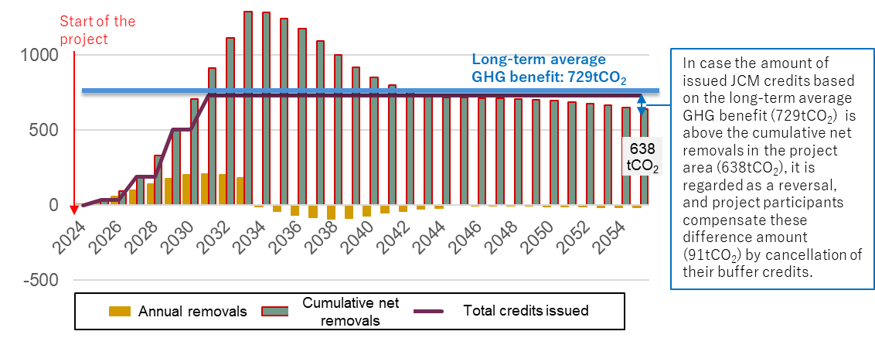

I.2. Calculation method of the long-term average GHG benefit
- The long-term average GHG benefit is calculated using the following procedure:
- Establish the period over which the long-term average GHG benefit is calculated as the following:
    - For afforestation/reforestation projects undertaking even-aged management, the time period over which the long-term GHG benefit is calculated includes at minimum one full harvesting cycle, including the last harvest of the rotation cycle included in the crediting period. For example, where a crediting period is 20 years and has a harvest cycle of 12 years, the long-term average GHG benefit will be determined for a period of 24 years.
    - For afforestation/reforestation with selective harvesting, the time period over which the long-term average is calculated is the length of the crediting period.
In both cases, the period is no less than the crediting period.
- Determine the expected cumulative GHG benefit of the project for each year of the established time period. For each year, the cumulative GHG benefit is the difference between the project net removals and project reference level.
- Sum the cumulative GHG benefit of each year over the established time period.
- Calculate the average GHG benefit of the project over the established time period.
- Use the following equation to calculate the long-term average GHG benefit, based procedures shown in (a) to (d) above:
$$LA= \frac{\sum_{t=1}^{n}{(PEt-REt)}}{n}$$
Where:
LA The long-term average GHG benefit [tCO₂e]
PE_{t} The cumulative to-date GHG emission reductions and removals generated during the project, including CO₂, CH₄, N₂O emissions reasonably attributable to the project activities, and displaced emissions [tCO₂e]
RE_{t} The cumulative to-date project reference level [tCO₂e]
t Year
n Total number of years in the established time period

Annex II. National definition of forest under the JCM of the PARTNER COUNTRY

- [Defined by each PARTNER COUNTRY]

Annex III. Guidance on buffer approach to address reversals

- A reversal is a situation that occurs if project emission reductions or removals to be credited (as referred to paragraph 55) in any monitoring period is negative. The amount of the reversal is the difference between the current total to-date project emission reductions or removals to be credited compared to the total (to-date) project emission reductions or removals to be credited at the previous verification.
- When a reversal is occurred during the crediting period, credits are cancelled to compensate for the reversal and ensure the permanence of issued JCM credits. The amount of credits to be cancelled is equal to the lower of (a) or (b):
- The amount of the reversal,
- The total amount of credits previously issued.
- To compensate for the reversal, the buffer credits, deposited from the project where the reversal has occurred, are cancelled at first. If the amount of buffer credits is insufficient, the deficit is to be replenished by the project participants, cancelling the credits of (a) to (c) below, and project participants describe the information of the credits, which will be compensated, such as project name, reference number, account name, account number, the amounts of the credits to be compensated in the “JCM Compensation Plan Form”. Other way for compensation (referred to (d)) may be used only when Joint Committee deems it difficult to compensate by (a)~(c). In case that the reversal is not compensated entirely within the certain time period, or the Joint Committee deems that the project participants aren’t addressing the reversal appropriately in line with Project Cycle Procedure for REDD-plus and afforestation/reforestation and Methodology Guidelines for REDD-plus and afforestation/reforestation, measures to be taken are determined by the Joint Committee.
- JCM credits issued by JCM projects (e.g., JCM credits previously issued from the project where the reversal has occurred, JCM credits issued from other JCM projects),
- Buffer credits from other JCM projects for which the crediting period has ended (in this case, the project participants ultimately have to deposit the equivalent amount of the credits to the buffer account),
- JCM Credits to be issued in the future, e.g. by continuing the JCM project where the reversal has occurred.
- Other way for compensation (This option may be used only when Joint Committee deems it difficult to compensate by (a)~(c))
- The share of the compensation between project participants from Japan and the PARTNER COUNTRY is specified based on the allocation of credits in a project design document.
- Until the full amount of the credits referred to paragraph 2 has been cancelled, the project participants continue to observe the project, and cannot earn JCM credits from the project that reversal occurred unless otherwise approved by the Joint Committee. This observation is not intended to calculate the net removals but simply to check the continuation of the project. Project participants may request the Joint Committee to issue JCM credits from the projects that the reversal occurred while the compensation for the reversal has not been completed.
- For REDD-plus, after a reversal occurred, the project participants review the entire project, including the long-term average GHG benefit, project reference levels and buffer rates, and revise if necessary. For afforestation/reforestation, after a reversal occurred, the project participants may review the entire project, including the long-term average GHG benefit, project reference levels and buffer rates, and revise if necessary.
- The buffer credits unused during the crediting period are kept in the buffer account in case of addressing the reversal occurred in the project area after the crediting period or in other projects.
- The buffer rate is more than or equal to 15 %. Project participants set the rate based on the project's reversal risk.
- Each JCM registry of Japan and the PARTNER COUNTRY has one buffer account, in which buffer credits are managed.

The following guides may be referred to for the estimation of net emissions or removals: “REDD-plus Cookbook: How to measure and monitor forest carbon,” Forestry and Forest Products Research Institute, 2012: www.ffpri.affrc.go.jp/redd-rdc/ja/reference/cookbook.html “A sourcebook of methods and procedures for monitoring and reporting anthropogenic greenhouse gas emissions and removals associated with deforestation, gains and losses of carbon stocks in forests remaining forests, and forestation”, GOFC-GOLD, 2015: http://www.gofcgold.wur.nl/redd/sourcebook/GOFC-GOLD_Sourcebook.pdf

